John Smith 5.2 MySQL Functions 2-2-2025

The INSERT () function inserts a string within a string at the specified position and for a certain number of characters.

**SELECT CURRENT_DATE();**

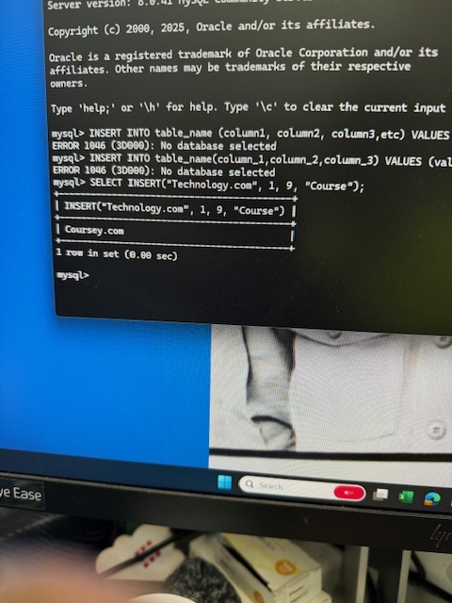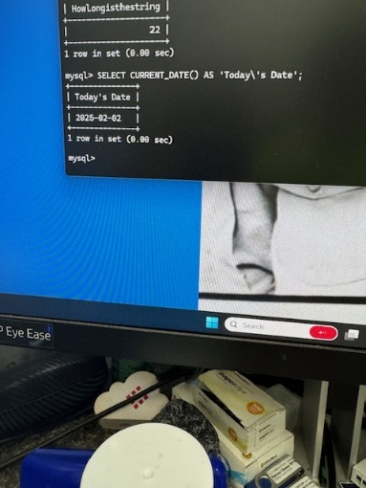

The LCASE () function converts a string to lower-case.

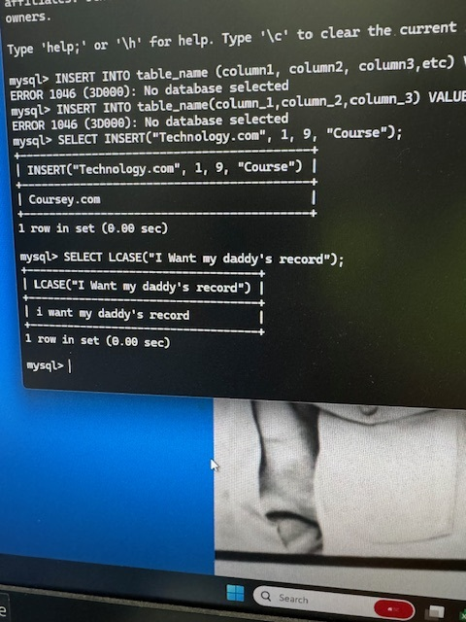

The LENGTH () function returns the length of a string (in bytes).

